Assignment #6 Naïve Bayes Classifier by Joshua Troup

**2. What is the probability that this customer will accept the loan offer?**

882 records where online = 1 and cc = 1

82 of them accept the loan

82/882 = .0929

**4. a) P(CC=1 | Loan=1) (the proportion of credit card holders among the loan acceptors)**

143/480 = .2979

**b) P(Online=1 | Loan=1)**

291/480 = .6062

**c) P(Loan=1) (the proportion of loan acceptors)**

480/5000 = .096

**d) P(CC=1 | Loan=0)**

1327/4520 = .2935

**e) P(Online=1 | Loan=0)**

2693/4520 = .5957

**f) P(Loan=0)**

4520/5000 = .904

**5. = (.2979 * .6062 * .096) / [(.2979 * .6062 * .096) + (.2935 * .5957 * .904)]**

**= .0173/(.0173+.1580)**

**= .0173/.1753**

**Naïve Bayes probability P(Loan=1 | CC=1. Online=1) = .0986**

**6. Compare this value in step 6 with the value from the crossed pivot table 1 in step 2. Which is a more accurate estimate?**

The value .0929 from the crossed pivot table is more accurate since it does not make assumptions on the probabilities of being independent.

**7. Which of the entries in this table are needed for computing P(Loan=1 | CC=1, Online=1)?**

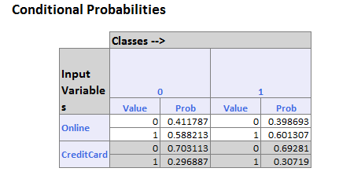

Entry 45 is CC=1 Online=1 Actual Class= 1 Prob for Success = .106 Prob for 0 = .89